Izvestaj o greskama V-3

Glavna greska se nalazi u servisu Server 4 (Express). Nastaje u fetchService.ts u getCourseTime metodi. Greska je sledeca:  
GET /raspored?dan=utorak 200 24.771 ms - 104

[1] [ { ime: 'WEB', trajanje: 50, brucenika: 24 } ]

[1] TypeError: body used already for: http://localhost:8080/Predmet/Prosek/WEB

[1] at Response.consumeBody (D:\Faculty of Electronic Engineering\TZPU\TZPU-main\4\Server4\node_modules\node-fetch\lib\index.js:344:30)

[1] at Response.json (D:\Faculty of Electronic Engineering\TZPU\TZPU-main\4\Server4\node_modules\node-fetch\lib\index.js:269:22)

[1] at FetchService.<anonymous> (D:\Faculty of Electronic Engineering\TZPU\TZPU-main\4\Server4\src\Services\fetchService.ts:26:27)

[1] at Generator.next (<anonymous>)

[1] at fulfilled (D:\Faculty of Electronic Engineering\TZPU\TZPU-main\4\Server4\src\Services\fetchService.ts:5:58)

[1] at processTicksAndRejections (node:internal/process/task_queues:95:5)

[1] [ERROR] 22:21:58 TypeError: body used already for: http://localhost:8080/Predmet/Prosek/WEB

Greska utice na funkcionisanje servisa, jer navedeni servis pukne jer se za isti body zove metoda koja vraca razlicite podatke. U slucaju zakomentarisanja tog dela koda gubi se na funkcionisanju celog servisa, jer se podaci ne prikazuju, samim tim gubi se na funkcionisanju cele aplikacije.

1. Client 4 - front end je razvijen u angular I pokrece se komandom ng serve
2. Server 4 - backend je razvijen u Node JS okruzenju I pokrece se komandom npm run all
3. Notification I PowerFailure se pokrece obicnim klikom na RUN
4. ClassRoom-Service se pokrece komandom mvn spring-boot:run
5. Rest-Json QuickStart se pokrece komandama:  
   - mvn clean package

- cd target

- cd .\quarkus-app\

- java -jar quarkus-run.jar

Server 4 vraca gresku prilikom pritiska na bilo koji dan u kalendaru



GET /raspored?dan=ponedeljak 200 28.994 ms - 108

[1] [ { ime: 'RG', trajanje: 50, brucenika: 22 } ]

[1] TypeError: body used already for: http://localhost:8080/Predmet/Prosek/RG

[1] at Response.consumeBody (D:\Faculty of Electronic Engineering\TZPU\TZPU-main\4\Server4\node_modules\node-fetch\lib\index.js:344:30)

[1] at Response.json (D:\Faculty of Electronic Engineering\TZPU\TZPU-main\4\Server4\node_modules\node-fetch\lib\index.js:269:22)

[1] at FetchService.<anonymous> (D:\Faculty of Electronic Engineering\TZPU\TZPU-main\4\Server4\src\Services\fetchService.ts:26:27)

[1] at Generator.next (<anonymous>)

[1] at fulfilled (D:\Faculty of Electronic Engineering\TZPU\TZPU-main\4\Server4\src\Services\fetchService.ts:5:58)

[1] at processTicksAndRejections (node:internal/process/task_queues:95:5)

[1] [ERROR] 21:49:29 TypeError: body used already for: http://localhost:8080/Predmet/Prosek/RG

[1] [ { ime: 'WEB', trajanje: 50, brucenika: 22 } ]  
  
Pritom se vidi da servis vraca dobre podatke predmeta  
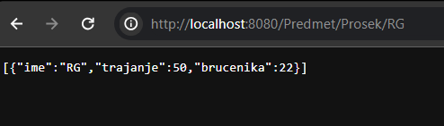

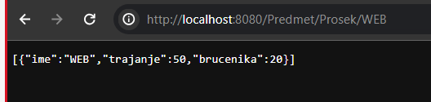

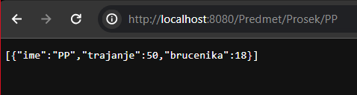

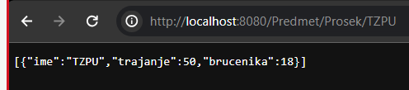

Gde su ovi predmeti u rasporedu za ponedeljak  
